Name:
Social Sciences Artifact Activity

1. Although you may know what the pictured item is, you must complete the organizer to earn credit for the question.
Artifact Image | Archaeologist ask? | Historian ask? | Geographer ask?
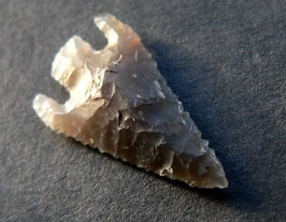

2. These items we will view in more detail, they are all items I use/have used personally. Complete the chart with observations and your inferences.

Artifact Image | My observations (think size, color, material, how could it be used...) | My Inference
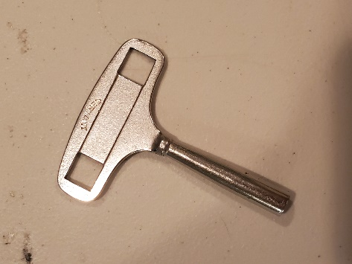
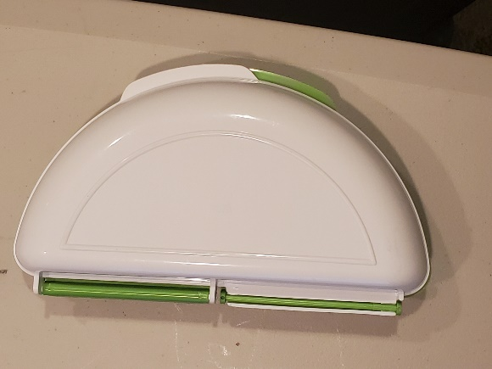
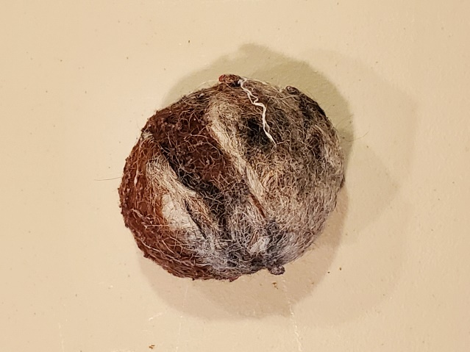
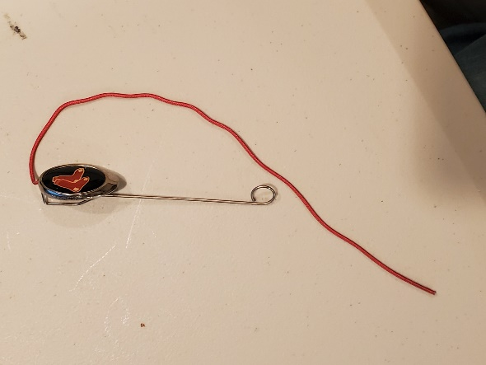

3. What did you learn about completing this activity/acting as a social scientist? Explain.

